Purpose
- To engage students in active observation and recording skills.
- To help students observe sky color, recognize that sky color changes.
Overview
This is an extension of the Elementary GLOBE Sky Observers learning activity. The full learning activity can be found on the GLOBE website under the Elementary GLOBE Air Quality module.
This extension allows students to practice recording observations and comparing their observations to discuss the differences between them. They will make an observation of their own to compare it with these images as well.
In September and October of 2019, there have been sightings of purple sunsets. This activity uses the Sky Observers Sunset Sky Report from the Elementary GLOBE Sky Observers activity with images of these sunsets to practice their observation and recording skills.
Student Outcomes
- Students will make observations of the sky, record their findings and share their observation reports with their peers.
- Students will also record observations of photographic images of the sky and share their observation recordings with their peers.
- Students will discuss the differences in sky color and the conditions that can lead to the colors in the photos.
Time
- Part 1: One 45 minute class period
- Part 2: 15 minutes for sunset observation during after school hours
- Part 3: One 30 minute class period
Level
Most appropriate for K-5
Procedure
- Use the Elementary GLOBE Sky Observers learning activity as a guide.
- In Part 2, students will only need the Sunset Sky Report. They can make one observation rather than doing observations for a week.
- Part 3
  - Give students at least one of the images provided.
  - Have students complete the Sunset Sky Report for the image provided.
    - If they cannot complete all data fields, explain that it is fine. They are comparing the images that have been colored. The main focus will be on trying to match colors as well as they can, not reproducing the image exactly.
    - Note: If students notice that the times seem to be in the middle of the night, explain that it is in UTC time. This is Universal Time Coordinated. In this way, scientists can be talking about the same time regardless of different time zones and places in the world.
  - Have a class discussion about the following ideas:
    - How were their own observations different from the photos?
    - Why do you think the color of the sky changes?
    - What colors were you surprised to see?
    - Discuss the impact of the volcanos on the atmosphere using the information provided below.
Volcanoes impact the atmosphere
As stated in the teacher notes of the Elementary GLOBE Sky Observers learning activity:
” The color of the sky can appear different colors because of many factors. The light from the Sun looks white. But it is really made up of all the colors of the rainbow. Sunlight reaches Earth’s atmosphere and is scattered by the gases and particles in the air. Blue light is scattered in all directions by the tiny molecules in the air. Blue is scattered more than other colors because it travels as shorter, smaller waves. This is why we see a blue sky most of the time. At sunrise and sunset, the Sun is lower in the sky. Its light passes through more atmosphere to reach you. Even more of the blue light is scattered, allowing the longer wavelengths like reds and yellows to pass straight through to your eyes.
The sky color is impacted by other atmospheric, or weather conditions. Small particles in the atmosphere called aerosols, can also impact the color. When there are relatively few aerosols, the sky appears clear and the color looks deep blue. As the aerosol concentration increases, all wavelengths of light are scattering giving the sky a more white color.”
According to Bob King of Sky and Telescope in an article titled Volcanoes Turn Twilights Purple, volcanic dust in the stratosphere continues to scatter the light during sunset when the sun is not going through the troposphere, or lowest layer of the atmosphere, anymore. That blue light combines with the read appearing sunset to make purple.
The article Volcanic eruption may explain purple sunsets published by the University of Colorado discussed the Raikoke volcano. This is a simplified summary.

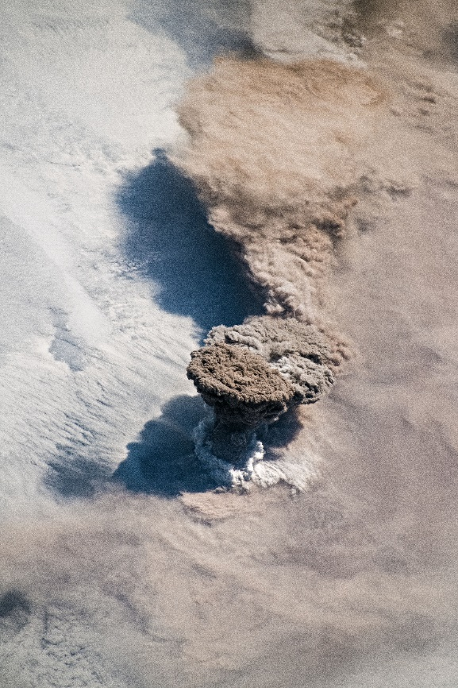
The Raikoke volcano in the Kuril Islands off the eastern coast of Russia, erupted on June 22, 2019. NASA wondered if the eruption spewed sulfur dioxide gas which looked like smoke into the stratosphere. This gas can lead to the formation of aerosols. The stratosphere is layer of the atmosphere that begins about 7.5 miles above the surface.
Scientists used a big balloon to see to see if they could find hints of that eruption in the stratosphere. In August, the team released a balloon near Laramie, Wyoming, and found that some aerosols in the stratosphere were 20 times thicker than normal after the eruption.

Simple Explanation
For a simple explanation, tell students the following.
- Light looks white but has many different colors in it that combine to make the white.
- When light hits things, it can bounce off them.
- Violet and blue light colors are shorter (wavelength) than other colors.
- These colors bounce off things the most.
- Because they bounce off things the most, they scatter or spread out the most.
- That is why the sky looks blue during the day.
- When the sun is setting, the sunlight is following a different path and we see more orange and red.
- Volcanoes can send gas and aerosols high into the atmosphere. It can go beyond the lowest part of the atmosphere.
- Light can bounce off these aerosols in the atmosphere.
- When the sun is setting, the blue light can still scatter higher up in the atmosphere if there are aerosols at that height. It doesn’t scatter lower since it isn’t shining lower.
- When the blue light scatters higher up and combines with the orange and red, it looks like purple.

Simpler Explanation
- Volcanoes can put tiny particles into the air.
- These tiny particles can make the sunsets look different colors
Sources

- “Globe Home Page.” #Language('Go-to') The GLOBE Program, GLOBE, https://www.globe.gov/web/elementary-globe/overview/air-quality.
- King, Bob. “Volcanoes Turn Twilights Purple.” Sky & Telescope, 4 Sept. 2019, https://www.skyandtelescope.com/observing/volcanoes-turn-twilights-purple/.
- “Volcanic Eruption May Explain Recent Purple Sunrises.” CU Boulder Today, 13 Sept. 2019, https://www.colorado.edu/today/2019/09/12/volcanic-eruption-may-explain-recent-purple-sunrises.
- “Raikoke Erupts.” NASA, NASA, https://earthobservatory.nasa.gov/images/145226/raikoke-erupts.

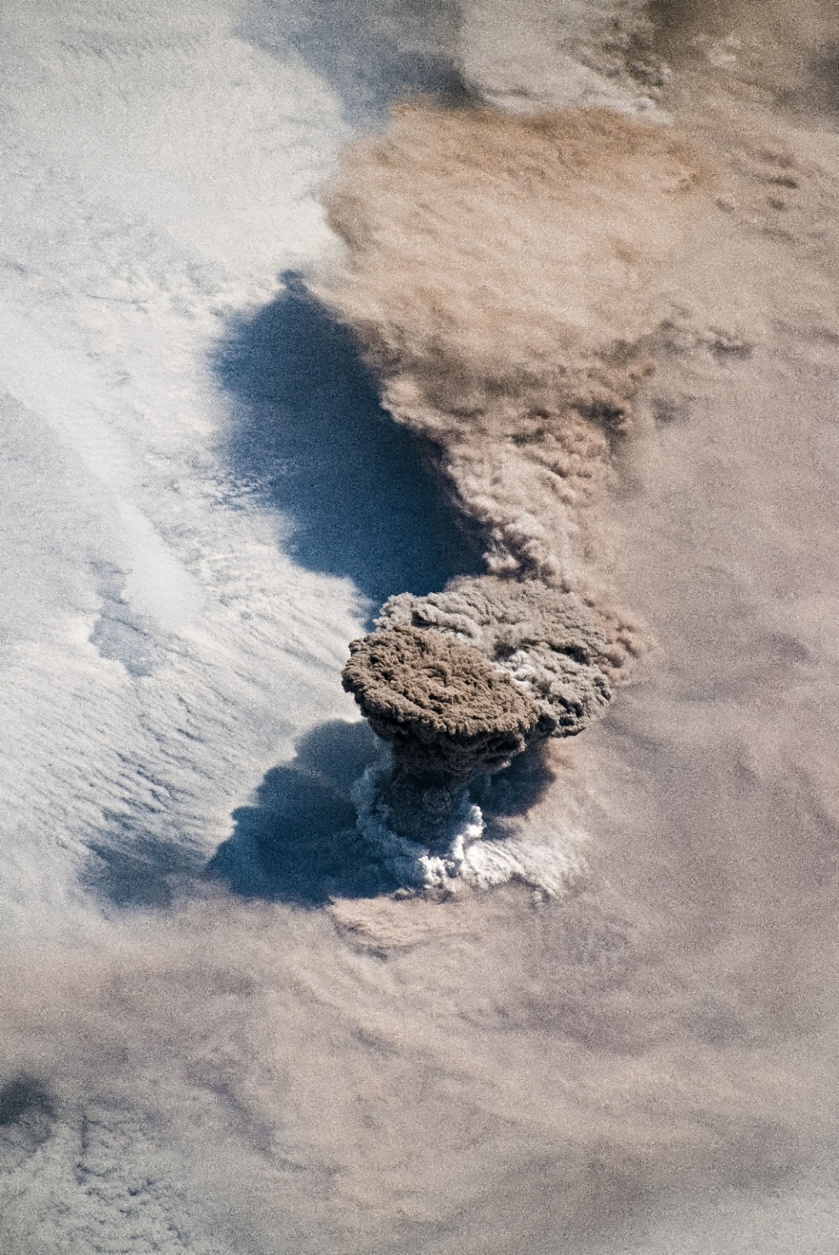

Raikoke Volcano, June 22, 2019 Image Credit: NASA Earth Observatory

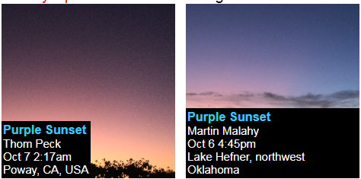
Images taken from https://spaceweathergallery.com/index.php?title=volcan&title2=purple

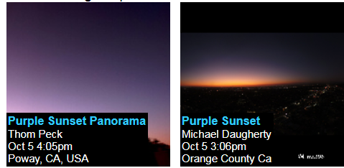
Images taken from https://spaceweathergallery.com/index.php?title=volcan&title2=purple

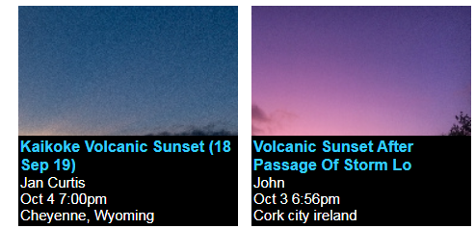
Images taken from https://spaceweathergallery.com/index.php?title=volcan&title2=purple
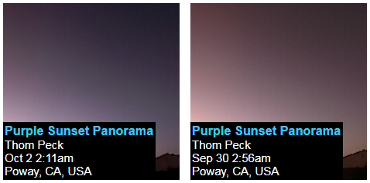
Images taken from https://spaceweathergallery.com/index.php?title=volcan&title2=purple
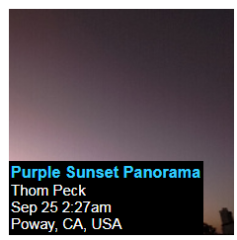
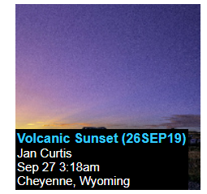
Images taken from https://spaceweathergallery.com/index.php?title=volcan&title2=purple

