- The Vantage Connect does NOT support GLOBE. Only the WeatherLink IP data loggers do. Confirm you have a WeatherLink IP Data Logger. (https://www.davisinstruments.com/product/weatherlinkip-for-vantage-stations/ )
- Make sure you have the WeatherLink software installed on your local computer and communicating with your Davis station. Weatherlink software comes with the data logger. Note this is not the same as the weatherlink website your station may already be reporting to.
Currently the software looks like this:
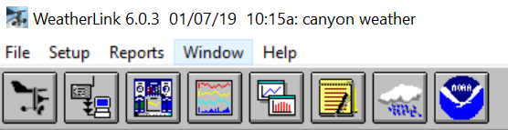

(https://www.davisinstruments.com/product/weatherlink-computer-software/ )

We assume the WeatherLink Software was setup already. If not, follow the Setup->Walkthrough instructions, or use the Davis help/tutorials/installation guides to make sure things are setup.

- Check if data archive is working:
  - From the weatherlink software, click the “download the weather station” icon (second in from the top) – check to make sure data is downloaded
  - Click “browse the station data” (yellow notepad icon) and verify data is there and is up to date
- If that doesn’t work - Reboot the console and see if it works
- If that doesn’t work then:
  - Download the data.
  - A console can stop logging archive records is if the archive memory gets corrupt. A “clear archive” command from the WeatherLink (WL) software on the local LAN might help. To clear the logger, make sure to close all other windows in the WeatherLink SOFTWARE and then select Setup and then Set Archive. Click OK. It will prompt you to clear the memory Say Yes
- If not - Check the data logger is in and working correctly
  - Please put you console in setup mode. By pressing DONE and MINUS at the same time (If a Vantage PRo 2) or 2nd, then DONE (if Vantage Vue)
  - Then remove the batteries. And the AC power.
  - Pull out the data logger.
  - Disconnect the Ethernet, USB or serial cable.
  - Check the pins where the data logger plugs in, and ensure you see 10 in each row, and that they all are straight.
  - Wait 2 minutes.
  - Reinsert the data logger.
  - Press VERY VERY hard!
  - Reconnect the cable.
  - Power up the console.
  - When you see the “Receiving from” or “Enter Time” screen, press BAR.
  - What does this screen show? This is important for any more diagnosis!!
  - Press and HOLD DONE for 2 seconds.
- Check pins on data logger and check baud rate
  - Can I have you fully power down the console (removing the AC power AND at least 1 battery) Pull out the data logger. Look at all of the pins very carefully, there should be 10 in each row and they should all be straight up.
  - Also on each end, there are 2 little tiny “flaps” that stick straight up. These should not be bent into the socket.
  - Once you check these, insert the logger pushing it in VERY VERY hard and then power up. How many beeps? (should be 3 beeps)
  - Again, when you get to the Enter time screen, press BAR one time. It should say Serial Baud Rate 19200. If it says anything else, it will be time to CALL us and get direct phone help.

